**Capstone Project**

Angular  
•Java  
•MySQL  
•SpringBoot

Docker, CI/CD and AWS Overview

Problem Statement

**Travel, healthcare, Entertainment and Food Delivery**

Backend -🡪 Spring boot with Micro Service (Optional) with Database MySQL

Frontend -🡪 Angular framework

login-app

type of user 🡪

Admin only one person is admin

With email id as [admin@gmail.com](mailto:admin@gmail.com) and password as admin@123

SignIn But no Signup

After login successfully open admin home page or dashboard

cid, type of car, fare, to, from etc.

mid, mname, qty, price, imageURL etc.

mid, type of moovies, show time, price etc.

fid, type of food, price, imageUrl etc

add, remove, update and retrieve end point etc.

admin can view all user or customer details.

Admin can view all order details.

Admin can view Product Or User or Order filter by

EmailId, PName, OrderDate asc or desc

User or Customer

SignIn and SignUp for user or customer.

After login successfully open customer or user home page or dashboard.

Two Rest API one for SignIn and Signup

Customer can view all generic product details with images. Then they can place the order.

Customer can view its own order details.

Login Entity class : emailid (PK), password and typeofuser

LoginController

LoginService

LoginRepository

Steps

Backend folder

**1st project : Eureka Server**

Eureka Starter

Web Starter

8761 port number

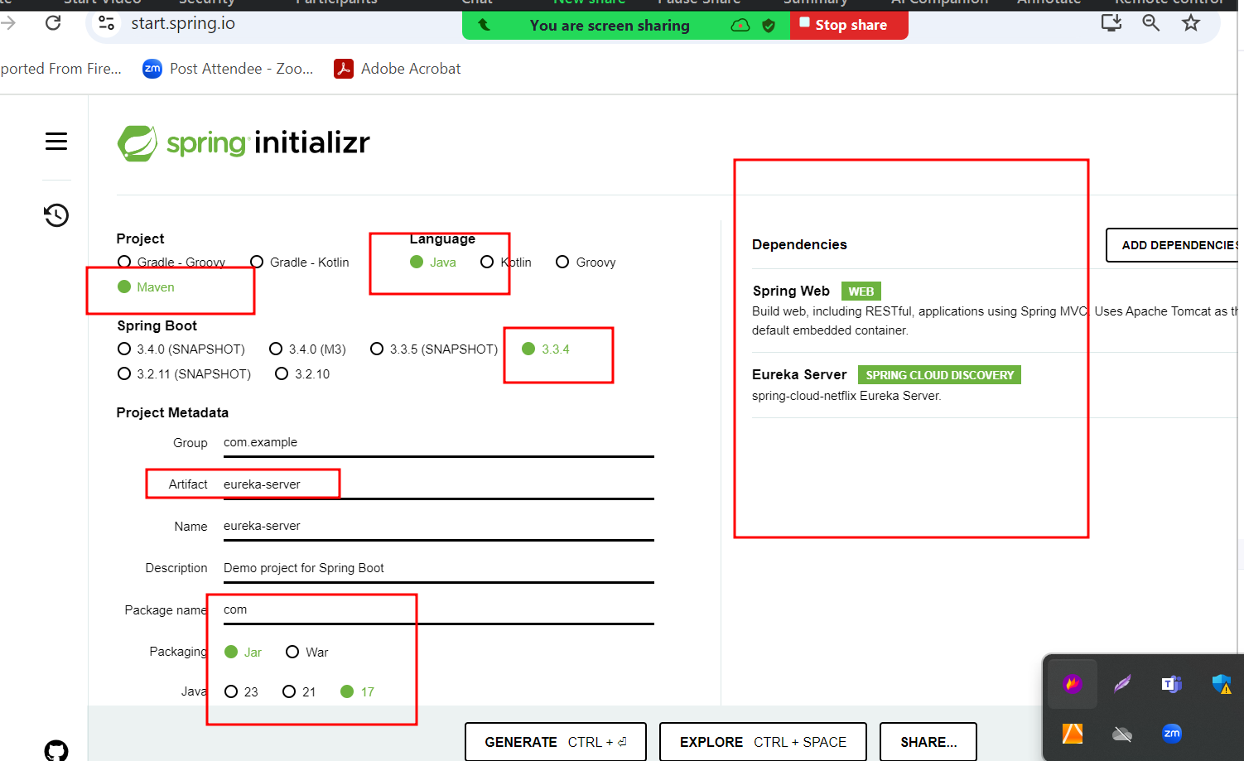

**backend-micro-service-app**

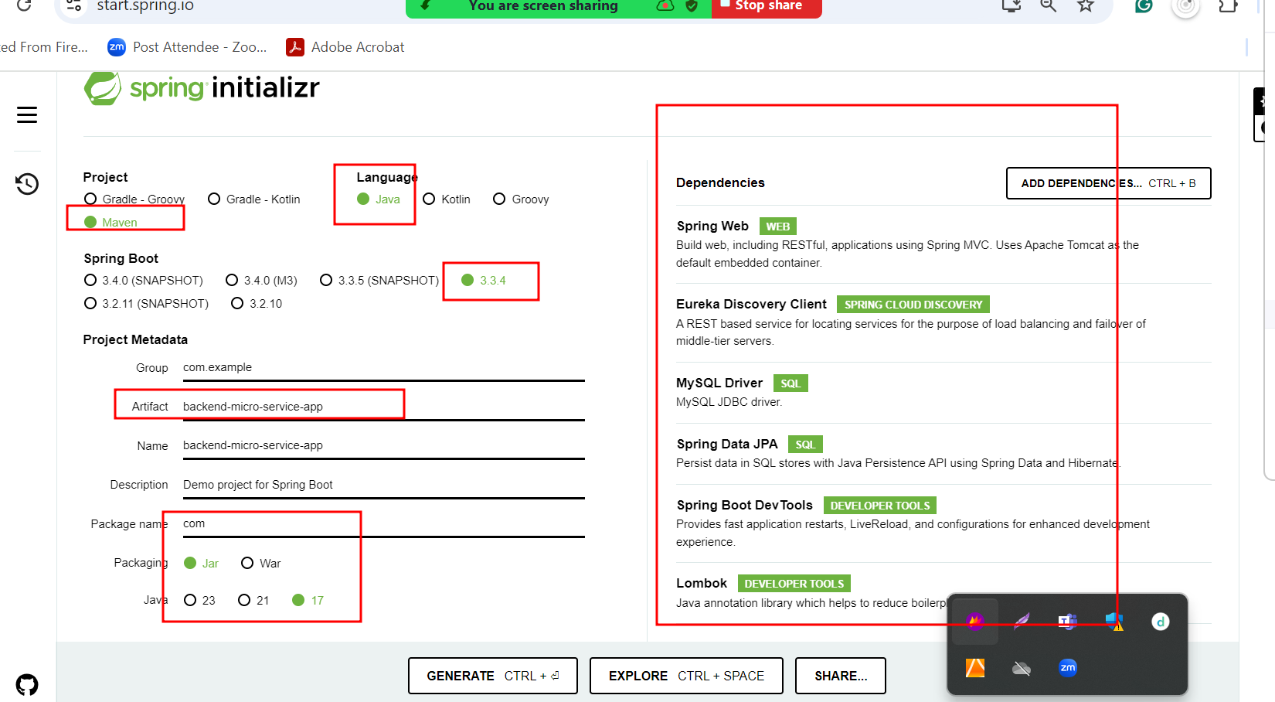

Frontend folder

Front end technology Angular :

From angular 17 onward app.module.ts file removed.

Please verify angular version it must be 16.x version

If 16.x version

ng new front-end-app

Routing 🡪Y

Styling 🡪 CSS

If more than 16 ie 17 0r 18.

npx -p @angular/cli@16.0.1 ng new front-end-app

Routing 🡪Y

Styling 🡪 CSS

Ng g c login this login component

Ng g c signup this command signup component

Ng g class login login model class

Ng g service login login service

Ng g c admindashboard admin dashboard

Ng g c customerdashboard customer dashboard